Spiritridge Family Science Night 2018
Tuesday April 24th, 2018 from 6:30-8:00pm

What is Family Science Night?
Come and have science-related fun! Family Science Night is the Science Fair and more! This is a school-wide event! Door prizes! Scavenger Hunt! Hands-on Science and Engineering Kits! In addition to the display boards by Spiritridge Scientists, we will have several community STEM organizations on display.
All Spiritridge students are welcome to attend Family Science Night!
Spiritridge students have two ways to participate in the annual Family Science Night. The first way is simply to attend Family Science to view all the Science Projects and tour other displays from local science organizations. The second way to participate is to register for the Science Fair and enter a Science Fair Project.

Please visit our website for project guidelines as well as registration:
http://spiritridge.org/Packet/ScienceFair2018

What is the Purpose of the Science Projects/Fair?
Students conduct scientific experiments according to the scientific method, and report their findings in a standalone (poster-board) presentation. The Science Project is a great opportunity for students to formally present those projects, to feel a sense of accomplishment for their work and to learn from each other.

Is Science Project Required?
All Spiritridge students can participate, from kindergarten through grade 5. Science Projects are only mandatory for grade 5 general education students. Depending on your class, it may be graded by your teacher. This is a participatory showcase, and will not be judged or evaluated. Our goal is for students to better understand the scientific process by researching a scientific question.
Science Fair is also an optional component of the Academic Challenge. For questions on Academic Challenge, please contact academicchallenge@spiritridge.org
Is there guidance on good topics?
The best topics, or really good questions, are ones that the student is interested in and can be tested independently by a student in a relatively short timeframe with relatively unsophisticated equipment. Topics such as “the solar system” or “when will the heat death of the universe occur?” are not good topics, because they are either not bounded by a specific question or require equipment (and potentially a lot of time) that is unlikely to be available to students.
A list of example topics has been made available, to help students who need a little extra help choosing a good topic. We have also provided a list of science pages to look at, so that your student can find ideas themselves.
How should my Student Approach his/her Project?
Students are expected to use the scientific method for their project, as described in the Spiritridge Science Fair Scientific Method Instructions and Outline. In practical terms, that means:
- Ask a scientific question
- Make a hypothesis (AKA “educated guess”)
- Design and execute an experiment that should answer that question
- Objectively observe the results of the experiment
- Write up the question, the hypothesis, the experiment, the observations and the conclusion (was the hypothesis right? Why/why not?)

What should the Project Write-up/Presentation look like?

The project should be displayed on a trifold display board. It should include a title, text, charts and pictures that describe and illustrate the chosen project. It should answer the questions listed in the provided scientific method outline.

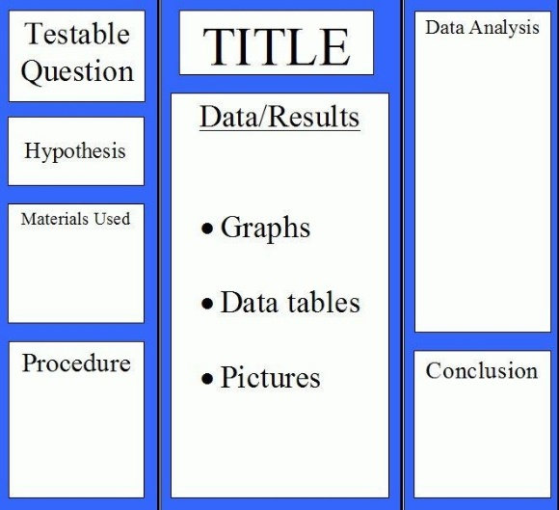

Display boards should contain the following:
- Student Name, Grade and Teacher (Mandatory)
- Your Question
- Your Prediction
- Your Materials List
- Your Procedure
- Your Data
- Your Variables
- Your Conclusion
Questions?
Feel free to contact Sadia Ali - dr_sadiaanees@yahoo.com

